Deploy Static Website on AWS

1. The S3 bucket is created as shown below

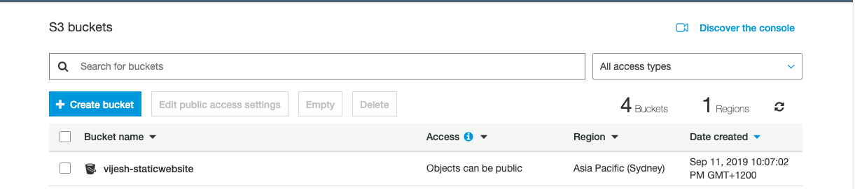

1. Uploaded all the required files to the bucket created in the previous step

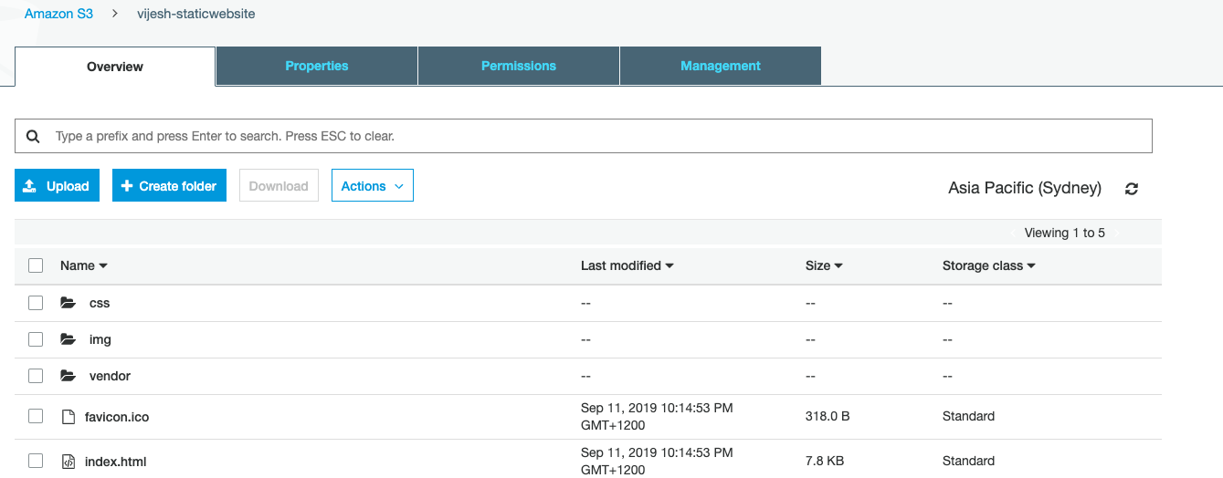

1. The S3 bucket is configured to support static website hosting

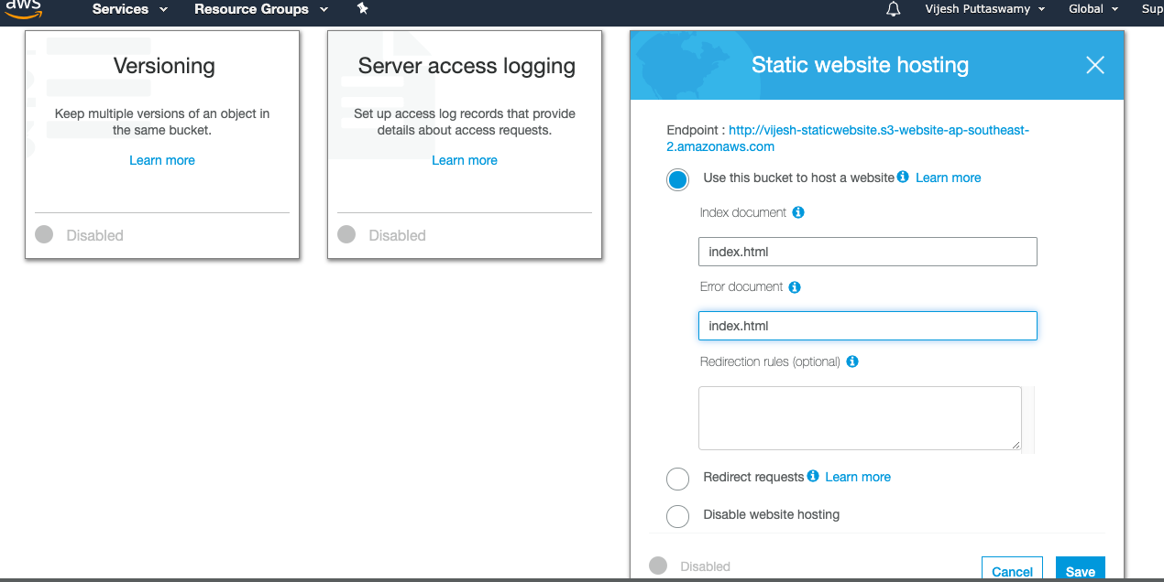

1. The S3 bucket has an IAM policy that makes the bucket contents publicly accessible.

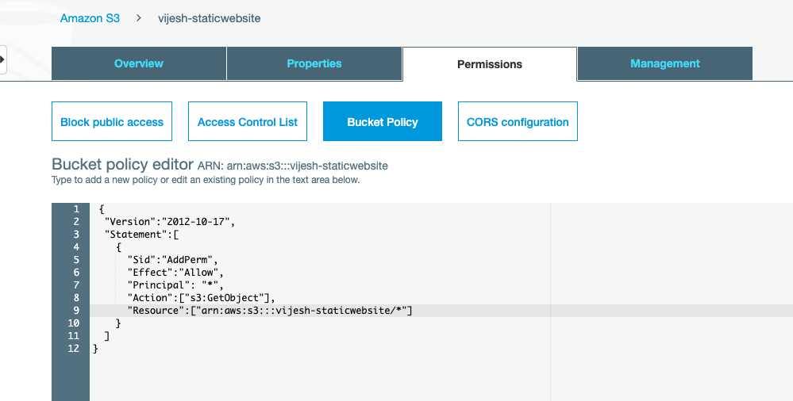

1. CloudFront has been configured to distribute website

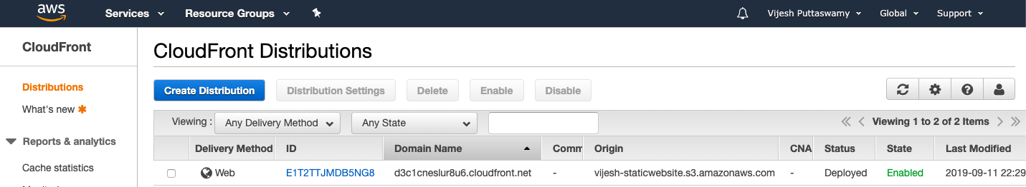

1. Website link as below:

d3c1cneslur8u6.cloudfront.net/index.html